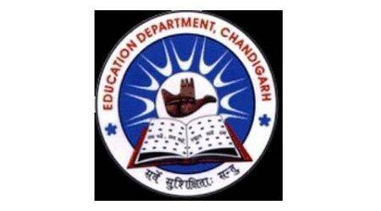
School Code : 24208 | Affiliation No. 2620025
GOVERNMENT MODEL SENIOR SECONDARY SCHOOL
SECTOR 38 WEST DMC CHANDIGARH. PHONE : 0172-2617001
Website: www.gmsss38wdmc.in. E-Mail ID: gsss38west@yahoo.in
ACADEMIC CALENDER
It is certified that the Academic calendar is according to the Chandigarh Education Department guidelines. Session starts from 1st April and ends on 31st March every year with Summer Vacation from 1st June to 30th June and Winter Vacation from 25th December to 5th January.
Examination Schedule is as follows:
Classes 3rd to 8th | Classes 9th and 10th
Formative Assessment : In the months of May and July.  Summative Assessment : In the month of September.  Formative Assessment : In the months of November and January  Final Assessment : March | Periodic Test : In the months of July ,September and December.  Pre Board : In the month of February – March(only 10th)  Annual Examination : March
Classes 11th and 12th
Unit Test : In the months of July and November
Terminal Examination : In the months of September and December
Pre board Exam : In the month of February and March (only 12th)
Final Exam : In the months of March and April
Time to Time, cultural activities and sports activities are organized along with participation in Science Exhibition and Excursion. Republic Day and Independence Day are also celebrated with full reverence.
NOTE : Due to Covid 19 in the present session 2021-22 , Online classes and activities are going on.

